Federation TAEKWON-DO ITF of Uzbekistan
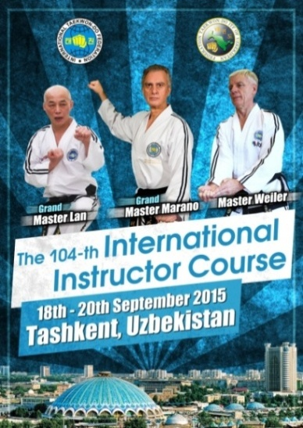

Dear Respected Grand Masters, Masters, Instructors and Students,
Federation Taekwon-Do ITF of Uzbekistan and I cordially invite you to the 104-th ITF International Instructor Course (IIC) to be held in the conference hall of “Le Grande Plaza” Hotel, Ovozi Str.2, Tashkent, Uzbekistan. The IIC dates are September 18-20, 2015 and will be conducted by the International Taekwon-Do Federation (ITF) Technical Committee:
      - Grand Master Hector Marano, IX degree, Argentina
- Grand Master Ung Kim Lan, IX degree, Germany
and Master Paul Weiler, VIII degree, Germany
The International Instructor Course will focus on Fundamental Movements, Dallyon, Patterns, Sparring and Self Defence.
The 104-th ITF International Instructor Course is open to all ITF members
1-st – 9-th Dan and Red and Blue belts. The ITF Promotion Committee will also be holding a 7-th and 8-th Dan Black belt Grading on Friday September 18, 2015 before first training session starts.
If you would like additional information, please, email us at itfuzb@gmail.com.
Federation Taekwon-Do ITF of Uzbekistan has secured rooms at “Le Grande Plaza” Hotel for its participants.
On behalf of Federation Taekwon-Do ITF of Uzbekistan and IIC Uzbekistan 2015 Organizing Committee,
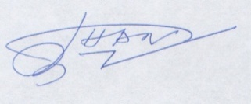
Master Han, VII degree
Chairman of the Board of Federation

Federation TAEKWON-DO ITF of Uzbekistan * Address: Mekhrjon-61, Tashkent, Uzbekistan *
Tel.: (+99871) 2914998 * Email: itfuzb@gmail.com
Federation TAEKWON-DO ITF of Uzbekistan
IIC INFORMATION:
VENUE
The course will take place atthe conference hall of “Le Grande Plaza” Hotel.
Address:
Ovozi Str.2,
Tashkent, Uzbekistan
COURSE ITINERARY:
REGISTRATION:
Thursday Evening 18:00 – 21:00: conference hall of “Le Grande Plaza” Hotel IIC Venue
Friday Morning: 10:00 – 12:00: conference hall of “Le Grande Plaza” Hotel IIC Venue
SESSIONS:
Friday:
13:15 – 13:50: All participants assemble in venue to await arrival of the Grand Masters and Masters
14:00 – 18:00: Course 1-st to 9-th degreeand Red and Blue belts, conference hall
Saturday:
08:15 – 09:00 Conference hall is opened. Participants line up waiting for the
technical Committee members to arrive
09:00 – 11:00 Course 1-st to 9-th degreeand Red and Blue belts, conference hall
11:00 – 13:00 Course 1-th to 9-th degreeand Red and Blue belts, conference hall
13:00 – 14:00 Lunch Break
14:00 – 18:30 Course 1-th to 9-th degreeand Red and Blue belts, conference hall
17:30 – 18:30 Dinner
19:00 – Late Banquet

Federation TAEKWON-DO ITF of Uzbekistan * Address: Mekhrjon-61, Tashkent, Uzbekistan *
Tel.: (+99871) 2914998 * Email: itfuzb@gmail.com
Federation TAEKWON-DO ITF of Uzbekistan
Sunday:
08:15 – 09:00 Conference hall is opened. Participants line up waiting for the
technical Committee members to arrive
09:00 – 13:00 Course 1-st to 9-th degreeand Red and Blue belts, conference hall
13:00 – 14:00 Certificate distribution and photo session, conference hall
14:00 – 15:00 Lunch Break
COURSE REGISTRATIONS AND PAYMENT OF COURSE FEES
INDIVIDUAL REGISTRATION
Countries must send “2-nd IIC Uzbekistan 2015 Individual Application Form” on or before September 1, 2015 to itfuzb@gmail.com.
FEES:
Red and Blue Belts and 1-st – 3-rd degree: 150$
4-th degree and above: 200$
BANQUET FEE:
30$
DEGREE TESTING:
TEST FOR DEGREE PROMOTIONS:
Participants wishing to test for promotion must:
- Send the application form through the National/Allied Association 1 (one) month before the promotion date to the ITF Administration HQ.
- Bring 5 wooden boards measured 30x30x2 cm. (Boards will be on sale at the venue if needed).
- Pay their ITF degree certificate and grading fee one hour prior to the grading.
- Test for degree promotion will be on Saturday afternoon.
- No spectators are allowed during the degree promotion.
- His/her instructor may accompany the candidate.

Federation TAEKWON-DO ITF of Uzbekistan * Address: Mekhrjon-61, Tashkent, Uzbekistan *
Tel.: (+99871) 2914998 * Email: itfuzb@gmail.com
Federation TAEKWON-DO ITF of Uzbekistan
ACCOMMODATION:
The IIC Organizing Committee secured double and single rooms in “Le Grande Plaza” Hotel. A Four Star deluxe Hotel in the heart of the city, a “Home away from Home” with its unique services.Ideal for Business&Leisure travelers with easy access to all financial & business institutions as well as touristic places.
Just 10 km or 15 miles drive from Tashkent International airport. Deluxe Service suits with all modern amenities. Free internet access. Dinnings& Lounges serving International cuisine, homemade pastries, fresh juices, hot and cold beverages. A fully equipped gymnasium, sauna, jacuzzi, massage & swimming pool.
If you wish to book the accommodation in this hotel you should send the “Hotel Application form” to itfuzb@gmail.com on or before September 1, 2015.
Double room: 64 USD per day (including breakfast)
Single room: 52 USDper day (including breakfast)
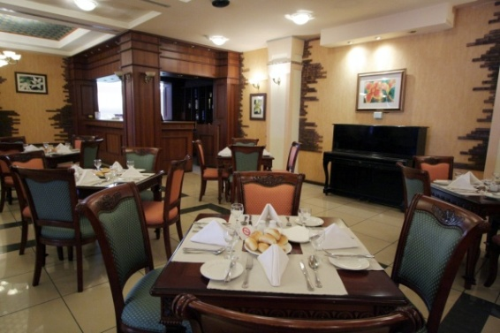
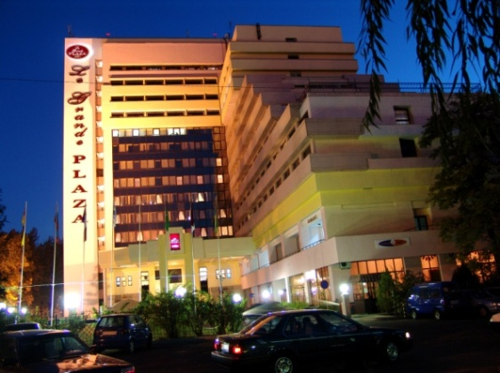

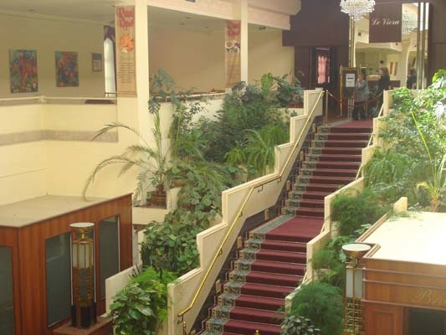
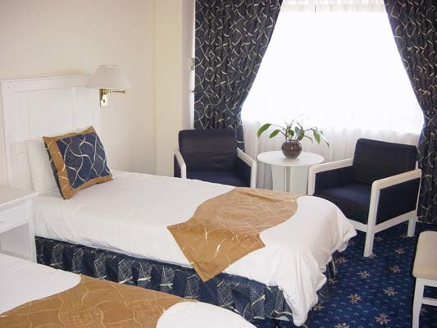

Federation TAEKWON-DO ITF of Uzbekistan * Address: Mekhrjon-61, Tashkent, Uzbekistan *
Tel.: (+99871) 2914998 * Email: itfuzb@gmail.com

